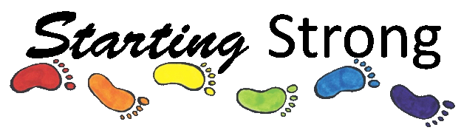
PARENT HANDBOOK
Our mission
: To provide all parents and children with affordable and educational class to attend- where early education and the outdoors are in partnership to create the best possible learning environment. Starting strong strives to achieve sustainable practices throughout the year and has a main focus on educating its young students on how to be environmentally conscious. All natureplay classes provide opportunities for unstructured play and child lead learning.
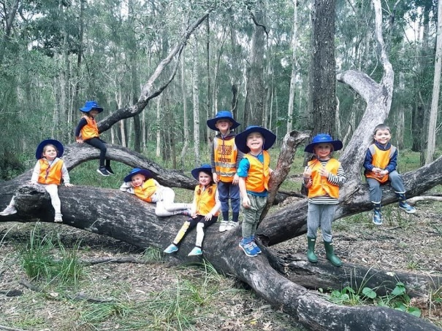

Our staff
Mandy & Jess are the co-founders and are professional, early childhood educators (ECE) with 20 years of experience in a vast array of childcare settings. They are first aid and CPR trained and hold a valid working with children ‘Blue card’. Feel free to ask about their individual qualifications and experience. All of our staff are qualified, experienced and hold a blue card.
Educators for each class in 2022 are as follows:
Ms Mandy
Ms Suzie
Ms Kelly
Ms Nel
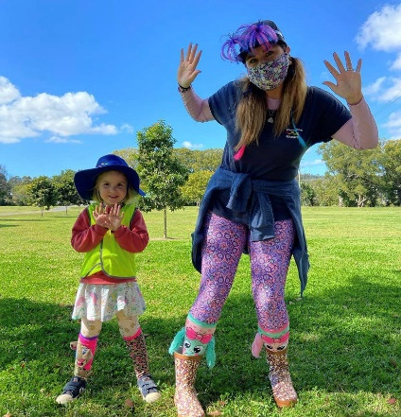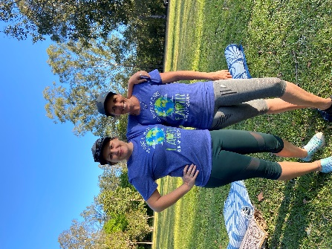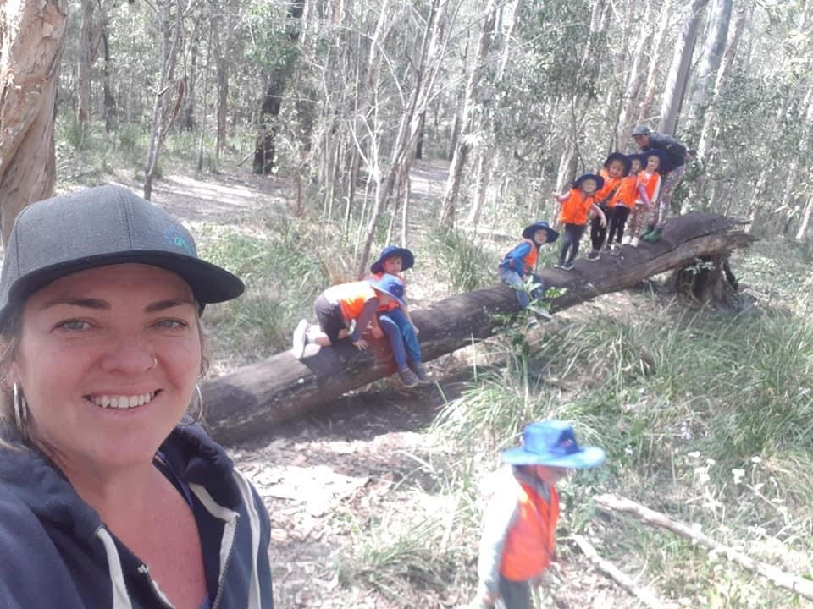

DIRECTORY
Class types
Class age groups
Fees /registrations
Cancellation policy
Start and end of class procedures
Absences /make up days
Full time registration / drop in days
Parent and sibling attendance
Social media / communications
Medication policy
Food policy
Accidents and safety
Guidance procedure
Illnesses and communicable disease policy
Cleaning and hygiene
-COVID UPDATE
Wet weather procedure
Contact details
Covid declaration
Bush program waivers

Our classes
Please note that we have three types of classes!
- Outdoor theme based classes. These classes follow a little routine and pre-programmed according to fun weekly themes. They are a great way to introduce your young learners to gentle rules and routine in preparation for school one day! They get to sample the 5 main learning areas in each session.

- Outdoor Natureplay classes often at rotating locations for winter and summer. These classes follow less structure and offer children more freedom to explore in their own unique ways.

- Homeschool classes * These take on a bush school approach whilst following our 7 main focuses and are lead by our qualified forest school leader, Miss Kelly.

*Please don’t hesitate to ask us any questions. Read below for a more detailed outline!

Outdoor theme based classes
These Classes are held at the beautiful Paradise Point parklands currently on Tuesday and Wednesdays , Or Laguna Park , Palm Beach on Tuesdays and Pimpama on Thursdays.
Research has shown that there are numerous ways that children benefit from being in the outdoors. With the sunny Queensland weather on our side combined with our vast experience in early childhood development -we decided to create a unique program for under 5s in the northern gold coast region. You can be guaranteed not to find a program for your child quite like Starting Strong! These classes cater to under 6s – more information regarding the age groups below!

Babies until walking are our… JOEYS
We have created a program perfect for little bodies and brains to learn and discover in their own unique way!
Start with songs, interactive finger puppets , and story time. Followed by options of fine motor and sensory activities which change each week. Next we move together to a group craft time or group sensory play to help encourage social interactions while playing. This class often schedules ‘special visitors’ for parent information sessions (eg: naturopath , sleep consultants , doulas , postnatal yoga to name a few!)

1-2 year olds ( up until their 3rd birthday) are our WALLABIES
The perfect program for this inquisitive and busy age group!
Class starts with circle time filled with music and movement, stories and interactive finger puppets. We then move on to our many options of fine motor and sensory play which changes each week to fit in with our theme! Together we move on to craft time – always a fun and often messy affair so keep that in mind when preparing and dressing for your morning. This ranges greatly to touch base on all different art styles. Finally we get to gross motor play to get some bugs out ( shape hunts , ball skills , parachute games to name a few) We then all sit down one last time for our good bye song and get a sticker for our charts. Parent involvement and participation in necessary in our toddler classes, please try to stay off your phone , get down on your child level and participate – this is the best way to model to your little one our routine and social aspects of the session. Each term wallabies class special ‘ learning focus’ for more info on this please just ask.

3-5 year olds are our KANGAS
Parents don’t attend this class but need to be nearby
Kanga kids need to purchase a sun safe bucket hat for the 2022 school year. This is $15 and included on the registration form.
Paradise point- This class is aimed to prepare your child for prep or pre-prep classes, with independence, confidence, writing and literacy skills and mindfulness.
2 hours and programmed on childs interest and skill levels.
Start with group circle time. Songs and stories and group games, this is also when your child will use their workbooks and learning focus activities ( feel free to email for more info) After circle time the children move onto our fine motor and sensory area followed by craft time! Next we will have a morning snack ( please ensure that this is nut free. We prefer if toys are not brought to class- just a lunch & drink in their backpack . Following our morning snack the kangas will enjoy some group games, science experiment or a discovery walk . We then will say good bye with a song – this is the que for parents to come and pick up !
Two times each term we are lucky enough to have a special inter-generational playgroup with our senior friends from Anglicare. We also have pen pals in Fernie, Canada and once a term will write a letter and have a community walk to the post office to mail it!

**The term programmed themes will be posted at the beginning of each term for parents to follow, we also recommend following starting strong on Facebook and Instagram for updates with activities and weather!

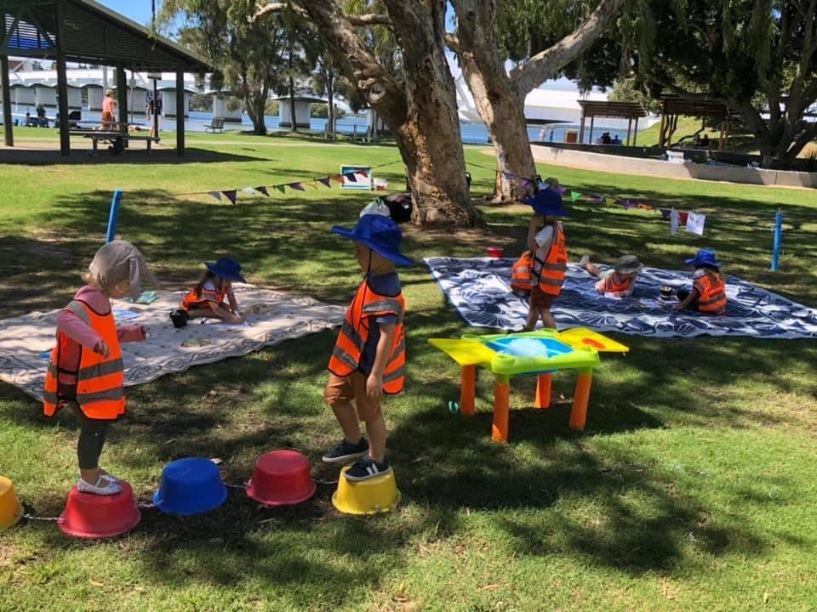

NaturePlay programs
FAMILY CONNECTIONS -All ages for 2 hours –parent participation required.
*Our family connections encourages all age groups / siblings /parents to attend and enjoy class together. Its very important for parent or caregiver to interact and supervise their child during these sessions- sometimes (especially during the first few weeks ) you may find your child needs a bit of encouragement and positive parent led exploration until they are comfortable and used to engaging their their imagination and instinct to initiate play without toys or prompting. Its really so amazing to watch this transformation within a few weeks of this nature based program . Our educators incorporate interactive story time , nature craft and activities into the session as well as bush walks!
FAMILY CONNECTIONS – Currently in Canungra on Thursdays and Coombabah reserve on Mondays.
KANGAS ( 3-5 yrs) 2 hours – Parents drop off /pick up
At bush kindy our children will have the opportunity to learn about the natural environment, how to handle risks and most importantly to use their own initiative to solve problems and co-operate with others.
Our Children will eventually use full sized tools, play, learn boundaries of behaviour; both physical and social, establish and grow in confidence, self-esteem and become self motivated. Our unique sessions move locations around the northern end of the coast with the seasons as children experience and get comfortable with mangroves , paperbark forests , wetlands , fields and all of the flora and fauna surrounding our 'play space'. We incorporate indigenous culture and respect into our sessions. Although all children can benefit from our sessions , they will need to be dressed comfortably , both child and parents need to be aware that there will occasionally be scrapes and bruises as result of our play and learning in nature and the elements.
Please refer to your newsletter for more info regarding correct clothing and what to pack.
KANGAS ( 3-5 yrs) 2 hours – currently On Fridays
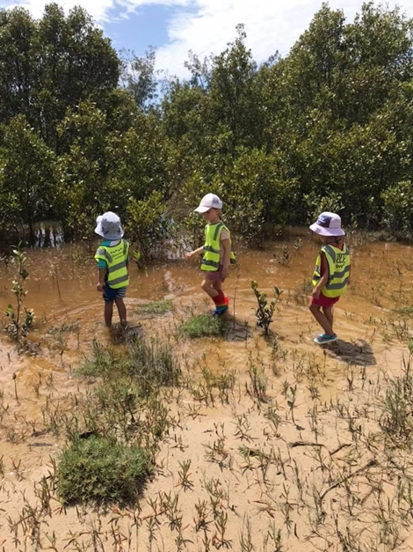
Homeschool Connections classes
Connections embraces our original goal of connecting the outdoors with community. Its was created with a different approach to learning for this new generation. A generation who are digitally native and live in a busy and often disconnected world. We wanted to create an opportunity to grow , learn , enjoy life in our slow , open and inclusive environment all whilst learning skills that may have been forgotten about by 2022. This brings us to our 6 focuses.
HOMESTEADING.
HANDICRAFTS.
PERMACULTURE.
OUTDOOR SURVIVAL.
CREATIVE UPCYCLE.
MINDFULNESS.
We currently offer these recreational classes to homeschoolers ( must be 5 -12 years old) . Wear clothes that can get dirty and easy to move around in and dress for the weather and seasons . Please email Miss kel if you have any questions regarding location and items – she will send out a newsletter at the start of each term with what to expect at each location.

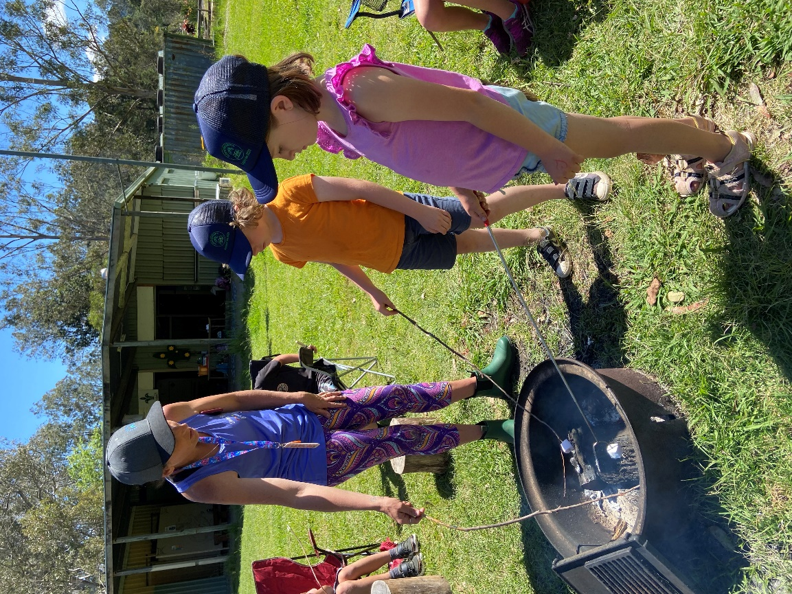

School holiday camps
We try to offer holiday camps as much as possible – especially during the summer break. These camps have a separate registration form but follow the starting strong guidelines and philosophies, waivers and declarations are also applicable.

Fees & registration
Registration is for the school year ( Jan 31st until Dec 2nd)
After the $50 insurance is paid fees will be taken our via direct debit on a fortnightly basis ( starting January 24th 2022)
Unfortunately we can not hold spots. Your spot is not guaranteed until insurance is made and registration forms are filled out.
Registration forms need to be filled out in order to attend class as they are also permission forms. Once you sign you are agreeing to all outlaid in this parent handbook including nature play waiver and covid declaration.
Cancellation / refunds
We understand that circumstances change- if you do need to cancel registration please email your one months notice to Mandy at startingstrong.gc@gmail.com
We can then refund the remainder of your fees following on from that month.
For school holiday programs unfortunately there will be no refunds.

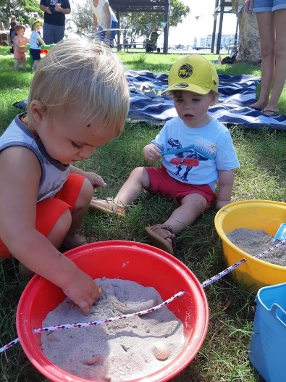
Start & end of class procedure
We ask that you arrive a few minutes early to class to give yourself time to sign in and let the staff know of anything that you feel maybe important before class starts. Please be aware that staff will be setting up until 5 mins before class, so please don’t leave your child unattended or playing at the activities.
For drop off classes , we would also like you to ensure your child has a hat and sunscreen on, has had a snack and gone to the toilet before class Please ensure your child is wearing appropriate clothing for the weather /season. Please don’t bring toys from home (unless the educator has discussed this ) and please no jewelry for children as it can be a hazard and can get lost! A clothing checklist will be sent out with welcome letters.
Class starts on time so please make sure you and your child (or for pre school class – just the child) are seated and ready for group time.
- If you are late your welcome to quietly come and sit down ( we will have books out to read if you are a few minutes early)
Programs where parents don’t attend:
Please make sure you sign your child in . Most Starting Strong sessions fall under Adjunct care which means ,parents must stay in the vicinity of our classes. Please ensure your phone is on ( not silent) incase we need to call you back to attend to your child.
At the end of class – please ensure that you have signed your child out. For the pre-school class we will dismiss them as we see you- please don’t interrupt the class before it ends – after your child has received their sticker we will direct them to you. Please note that if someone else is picking up your child (not the parent/ guardian that dropped them off) please let staff know who it will be ( Full name ) staff will need to ID that person if it is someone they haven’t met before, this is standard practice for all childcare facilities, ( so please make sure your pick up person has PHOTO ID with them) Your childs safety is our priority.
Absences
We give one make up day per term, please let us know which day you choose ahead of time.
If you are going to be away please contact us via email or face book or txt message.
** Edit due to new covid rules . Please stay home if your child has any symptoms or feeling unwell. We are happy to offer more make up days per term ( whenever we can , its not always possible )to encourage families to stay home if they are sick. These make up days are to be taken within 2 weeks of your absent day.
Cancellation of enrolment
Directors reserve the right to cancel enrolment at any time . We will discuss this with the parent and email a written letter regarding the reasons for cancelation.
Full time enrollment
Due to disruptions to the programming and for learning consistency we do not offer drop ins or part time term dates ( eg every second week to co-ordinate with C & K schedule) .
We also can not offer trials or one off bookings . We will offer open days each school term for families to come and have a look at the fun classes on offer!
Parents & Siblings
Parents or caregivers need to attend with the toddler & Infant classes
Parents or caregivers do not attend the pre-school (3-5 years) class but still need to be in the paradise point area. Please be aware that if you sit close by where your child can see you it can get disruptive as you child will most likely want to run over to you and tell you what they are up to! Our guideline is you can see us but please make sure we can not see you!
During the toddler class where parents attend – younger children (0-11mths) are welcome to join free of charge, however siblings 12 months or older will need to be registered in a class.

Medication policy
No medications can be given by staff – if your child will need medications during class times please discreetly take your child out of class to administer his/her medications.
Staffs need to be aware of all (ongoing) medications on the registration form and current medications can be verbally discussed with the staff. A care plan is to be filled out and attached to registration form.

Snacks
There is only a snack time during the 2 hour + classes. Please be aware of any class allergies and be respectful of that child when packing snacks. You will be informed of any class allergies in the welcome email. Please try to pack a few healthy options as we like to start our snack time with these first!
During the one hour classes we prefer if your child doesn’t eat snacks due to class disruptions ( other children then want to get snacks too!) However you are welcome to have a little snack time together when the educator is finishing class with the good by group time.
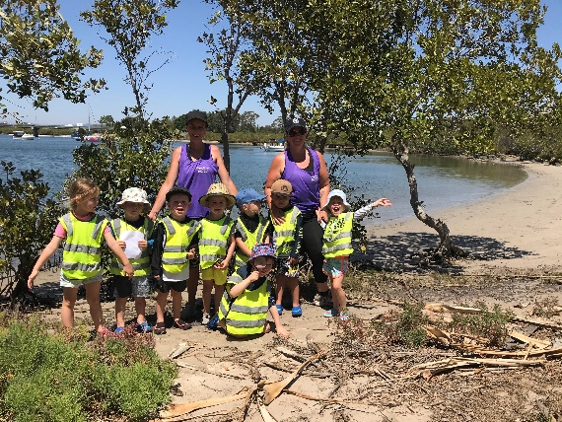
Social media/ communication
Please stay updated with special events /re-enrollment dates and other news by checking your email and our facebook page before each class. We post on facebook frequently , if you do not have facebook please advise so we ensure important information is emailed through.
Class activities are posted on our page, when you sign the registration form you are signing permission for us to display photos of your child for media purposes. This includes but not limited to social media , flyers , newspaper articles ect.– if you don’t wish for your child to be featured please just let us know so we can respect your wishes.
Accidents and safety:
Major
Parents will be immediately called over to the class to take the child to a medical facility
Minor
Staff will comfort the child – if medical attention is needed the parent will be called over to administer (antiseptic /band aids ect) we will have a first aid kit on site that parents are welcome to use.
Involving another child
Staff will ensure that all children involved are safe and given the opportunity to explain the incident. At the end of the class, staff will record the incident.

Guidance procedure
Staff will encourage and guide respectful behavior for all class members. Children and parents will be made aware of the behavioral expectations which are in place to make all families feel included and safe. During the class children who use hurtful words and actions are explained why the behavior is hurtful and unacceptable. They are given opportunity to discuss this with staff. We encourage parents to also follow up with the child and discuss safe and friendly choices. If a child continually shows unacceptable behavior we will do our best to come up with a ‘team plan’ between the staff , parents and child to ensure continuation of classes.
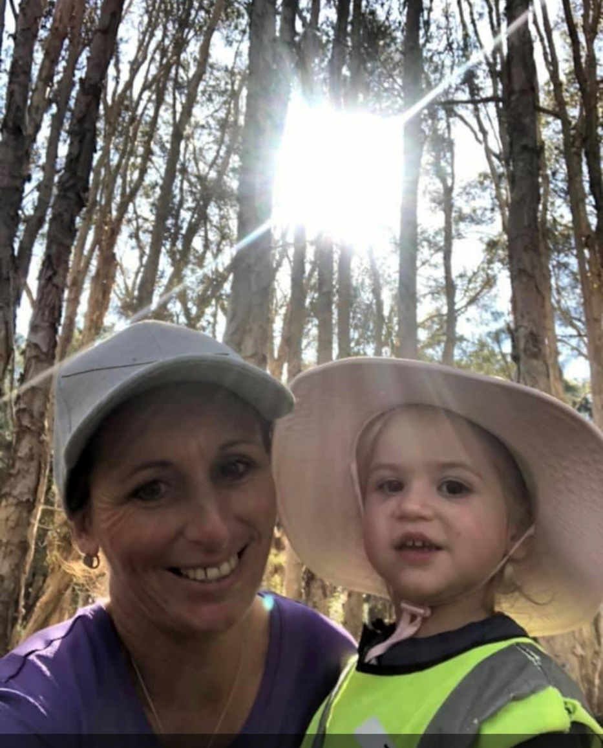

Illnesses and communicable disease policy
If your child is sick please do not bring them to starting strong classes – you are offered make up classes. This includes cold and flu symptoms and any other childhood illnesses. Staff have a right to refuse care/classes to any children that they feel is sick /may have signs or symptoms of illness. We will discreetly do this. If your child does have an illness /communicable disease please inform us as we can then email other family’s awareness of the illness and an information sheet. All information given to us will remain confidential. We don’t want any of our little friends or our amazing educators getting sick!

Cleaning and hygiene
At starting strong keeping kids healthy is important to us. Unlike typical child care facilities and play groups we rotate our toys and equipment each week. Classes often use different activities daily minimizing cross contamination. At the end of each class all equipment is sprayed down with a disinfectant and left out in the sun to dry and kill bacteria. There are many ways that bacteria can spread especially in our busy lives these days and our little ones are often exposed to this possibility in many circumstances from shopping centers and school drops off and via friends and relatives in social settings. Please be aware that staff do their very best to restrict the spreading of germs while at starting strong.

COVID -19 update
For the safety of all our little students and their families please adhere to our updated policies.
- Only one family member to join us for classes in our Joey and Wallaby classes and only one family member to drop children off to our Kanga and connections classes
- Please wash hands before joining us at group time. We will always have a hand sanitizer out and available each day.
- If you are sick / showing any cold / flu type symptoms or someone in your family is showing symptoms, please do not come to class. Staff have the right to politely ask you to not attend that day and to request a make up day.
- If you or someone in your family has travelled to an area where QLD government has restricted in the last 14 days please do not come to class.
- Please practice physical distancing with other parents. We understand this is not applicable to children.
- If you child has mouthed a toy please inform staff so they can place it in our disinfectant bucket.
- We will be ensuring our class areas are separated from the public by our bunting. If you are concerned about the public getting too close to our class area please let staff know.
- If a class is cancelled due to LOCKDOWNS we will do our best to offer make up days to all who missed out on their regular class. Emails will be sent out regarding this. However please note we will not be issuing refunds if class is missed due to government mandated lockdown and make up days are up to the discretion of the director and the many factors that contribute to make up days. We are a small Not for Profit organization that has been affected financially by lockdowns.

Complaint procedure
Starting strong believes in communication with parents, children, staff. If a situation may arise that you feel is a concern that needs to be addressed -a Verbal or written concern can be directed to Mandy at startingstrong.gc@gmail.com

Wet weather procedure
As we are a outdoor program we will try to run classes in most weather types. If the weather seems to dangerous we will post on facebook and send out emails no later than 30 mins before class ( we try our very best to do this the day before but its not always possible) This usually will be setting up in shelters at the park or moving to our back up location inside a community hall. Please always check on FB or email , We do ask that you also use common sense and dress your child ( and yourselves) accordingly whether its hats and sunscreen on a hot day or rainsuits and boots on a windy/wet day. Theres no such thing as bad weather – only inappropriate clothing ! A positive attitude to the weather is also very helpful as we all know our little guys are always checking in and following our lead on our reactions to everything! Please note that natureplay classes almost never uses the back up locations – we are teaching the children to embrace and learn in all weather types!

Contact details
Enrolment NTH GC and CANUNGRA: Kelly.startingstrong@gmail.com
Enrolment STH GC : Nel.startingstrong@gmail.com
All other enquiries : startingstrong.gc@gmail.com
Phone: 0449029393
Facebook: www.facebook.com/pages/starting-strong
And Instagram @startingstrong.gc
BELOW IS OUR :
Covid declaration
Bush school waiver
Upon registering via snapforms YOU AGREE TO THE PARENT HANDBOOK IN THE ONLINE REGISTRATION YOU ARE AGREEING TO THE DOCUMENTS BELOW.
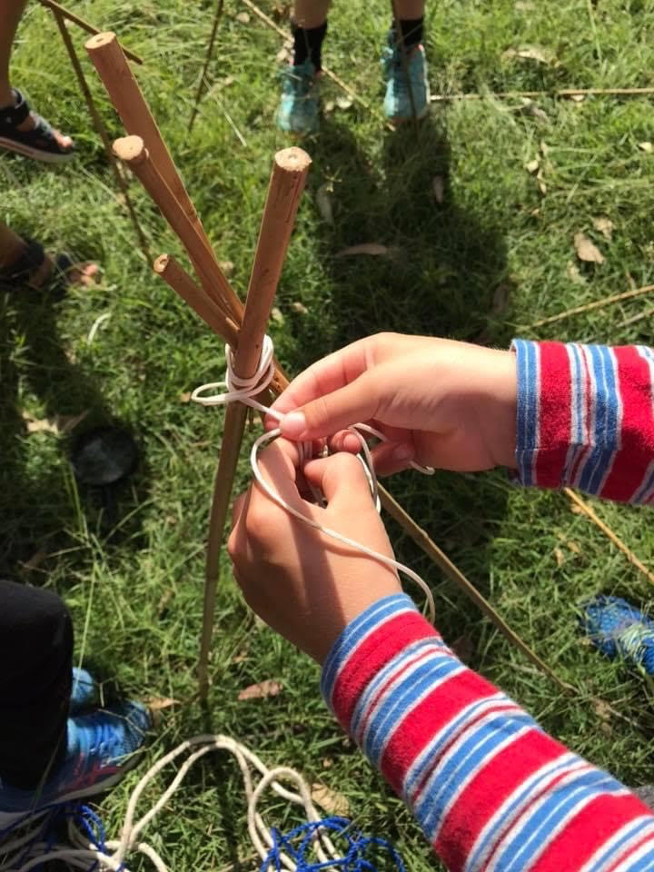

COVID DECLARATION
I understand that if I travel to a location where QLD government requires a 14 day quarantine , I will not attend class and inform the director via email startingstrong.gc@gmail.com or ph: 0449029393.
I will not return to class until I have communicated with the director and have been approved to return to classes with Starting Strong Inc.
I understand that If I or someone in my household has been in contact ( knowingly or unknowingly) with someone who has Covid-19 . I will not attend class for the 14 day period and not return until I have communicated with the Director of Starting Strong Inc.

I understand that my contact details on the registration forms can be used for contract tracing and I will update them if they change while I am attending Starting Strong. If Starting strong does not have my registration form before the first day of class I / my child can not attend.

I understand that If I/ my child show any symptoms of Covid- 19 , I will not attend class.

CAMPS and SCHOOL AGED PROGRAMS Behavioral guidelines
Due to the nature of camp day being all outdoors in bush and creek terrain with local wildlife – we do need all children to be able to listen to rules and directions at all times. Staff have been leading school aged camp days for 10 years and although with our smaller groups we can sometimes be more flexible , with larger groups in these settings we do have some structure to our day and a few guidelines they will need to adhere to. There is a lot of time allocated for child led free play / exploration and creativity . There is also a responsibility that we have to ensure all children are safe at all times which is why we will have certain guidelines. We will run through these with the children at 10am once everyone has arrived . We are aware that we will need to give reminders , however if your child can not follow the guidelines we have reminded them of , we will call you and they will need to get picked up within a 1 hour time frame. No refunds will be given. Please discuss this with your child beforehand.
**It is your responsibility that your child comes prepared for long days outdoors. They are dressed appropriately and have enough food and water for the day. Emails regarding this will be sent out before each full day program.

STARTING STRONG NATURE PLAY SESSIONS WAIVER

I grant permission for (printed full name of participant)

_________________________________________________________

to participate in all activities during Starting Strong natureplay sessions.
I understand that participation in activities can expose the named participant to risk and possible injuries.
I understand that there is a qualified certified First Aider on site and grant permission for them to treat the above named participant in the event of an injury.
I understand that by signing this document I hereby release Starting Strong from any and all liability associated with the program my child is attending.
I have read and understood the information contained in the Parent Handbook
I recognize that starting strong reserves the right to postpone or cancel programs/sessions due to unsafe weather conditions or other unforeseen circumstances. Where possible starting strong will attempt to reschedule, but this may not always be possible. I will not hold starting strong liable for loss of fees or programs.
All tools and materials will be provided by starting strong. Participants are discouraged from bringing additional items to sessions as they may be lost or broken.
I understand that it is my responsibility to ensure that the named participant is dressed properly for weather conditions as this is a program largely based outside in natural settings.
While participating in the starting strong program, I understand that the named participant will be required to listen and follow the guidance of educators. This includes participation in outlined activities, expectations for age appropriate behaviour, and able to respect the health, safety for themselves and any member of the group. If for any reason the named participant is unable or unwilling to follow expectations, engage in acceptable behaviour, or acts in an unsafe manner towards themselves or others, they may be removed from the session or the entire program.
I understand that starting strong reserves the right to deny access to a participant who has been disruptive in the past or sent home because of behaviour issues.
In the event that: the participant’s behaviour is felt to be unsafe or unmanageable, if an illness or injury should arise in which a doctor's diagnosis is required, unsafe weather conditions develop other unsafe conditions develop that require participant’s removal from program I will be contacted and will pick up my child immediately.
I am aware that for the above reasons I need to have my phone on me while my child is participating in Starting Strong Bush school and make staff aware of any phone number changes. That I will be in the outdoor classroom vicinity while the named participant is attending.
I acknowledge that I have read and fully understand this agreement, and accept the risks involved with the above named participant’s engagement in these activities at Starting strong and its outdoor natureplay sessions.

Signature

Print Name

Date

